#### Politician Name: Dilma Rousseff

**Introduction:**

Dilma Rousseff served as the Brazilian president from 2011 to 2016.

**Search Result:**

**Frequency:63**

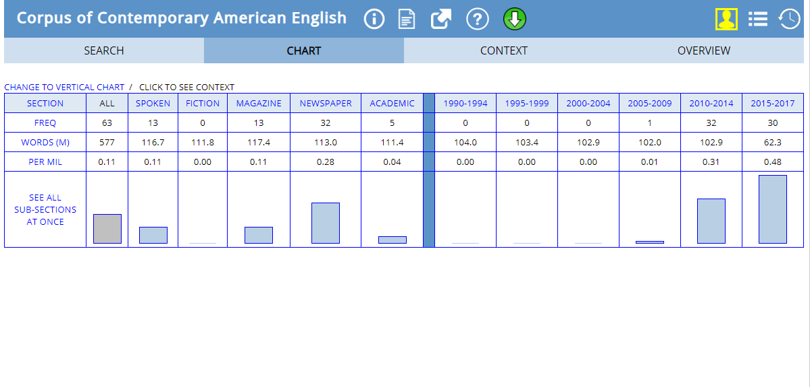

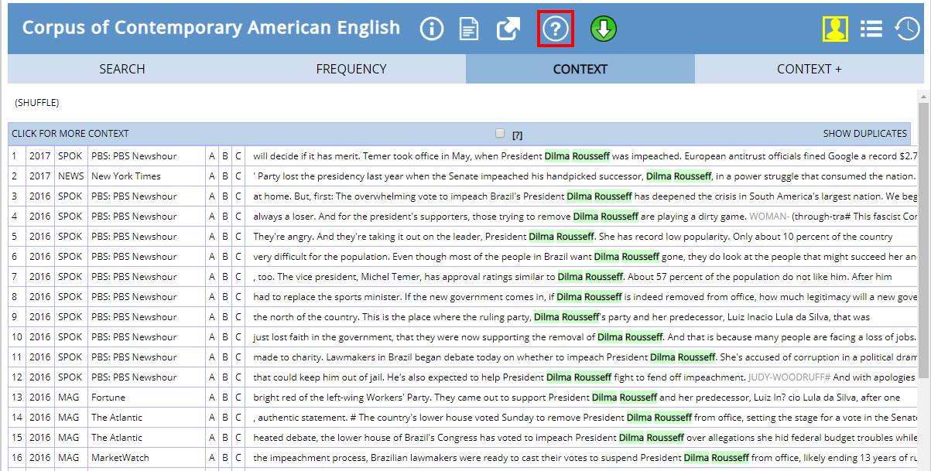

She was in the news and quite talked about in 2010 -2014, when she was elected as the president of Brazil. She was known as the first democratically elected president of the world.

She was most talked about in 2015 to 2017 when she was removed from her post. On 2nd December the petition for her impeachment was accepted. She was charged with misconduct with the federal budget and criminal administrative misconduct. On 31st august 2016, the senate suspended Rousseff’s powers and found her guilty for violating Brazil’s budget laws.